Teledu
Beth wyt ti’n gwylio?

Resource | Teaching and Learning | Notes
PowerPoint  2. Wyt ti’n  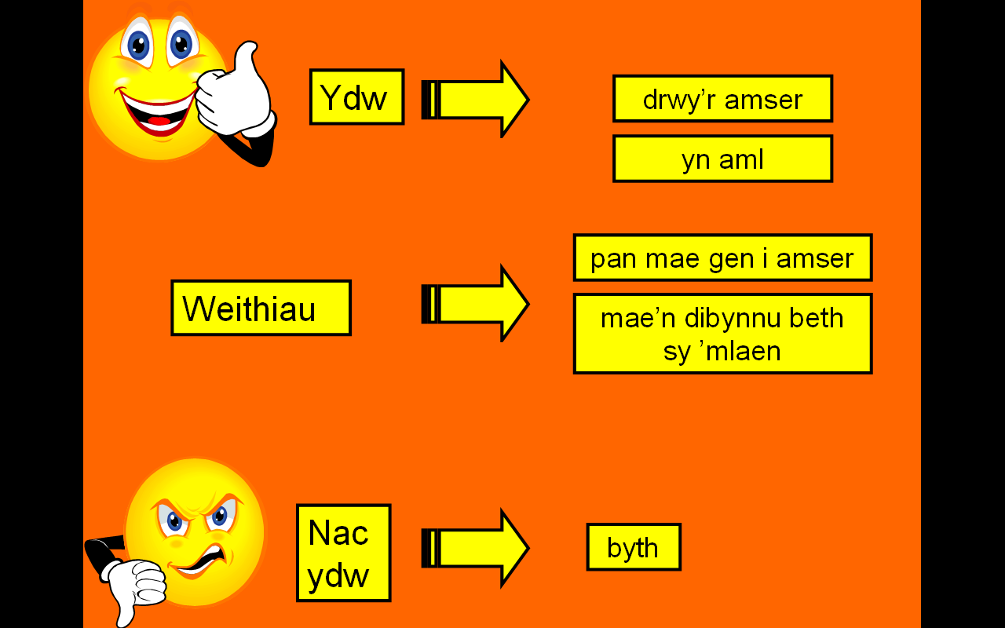 | - Aims to extend pupils’ answer to the questions ‘Wyt ti’n gwylio’r teledu?’  - Click to reveal positive and negative answers.  - Click to reveal the question followed by possible answers highlighted in green to display to pupils how easy it is to extend the answers.  - Pupils to give answers, working in pairs and as a whole class.  - Having practised, conceal the slide and ask pupils to answer again. | Effective use may be made of mini whiteboards throughout this section.
Word Document  3. Chwilair Teledu  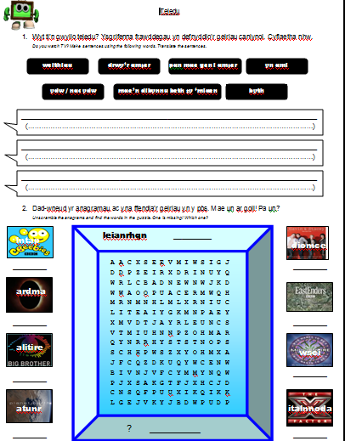 | - Pupils write sentences using the words and phrases learnt with 2. Wyt ti’n  - Pupils translate the sentences in brackets to demonstrate understanding.  After slide 2 of file 4.Beth  - Pupils to unscramble the anagrams and find them in the wordsearch, making a note of the one that is missing.
PowerPoint  4. Beth  Slides 1-2  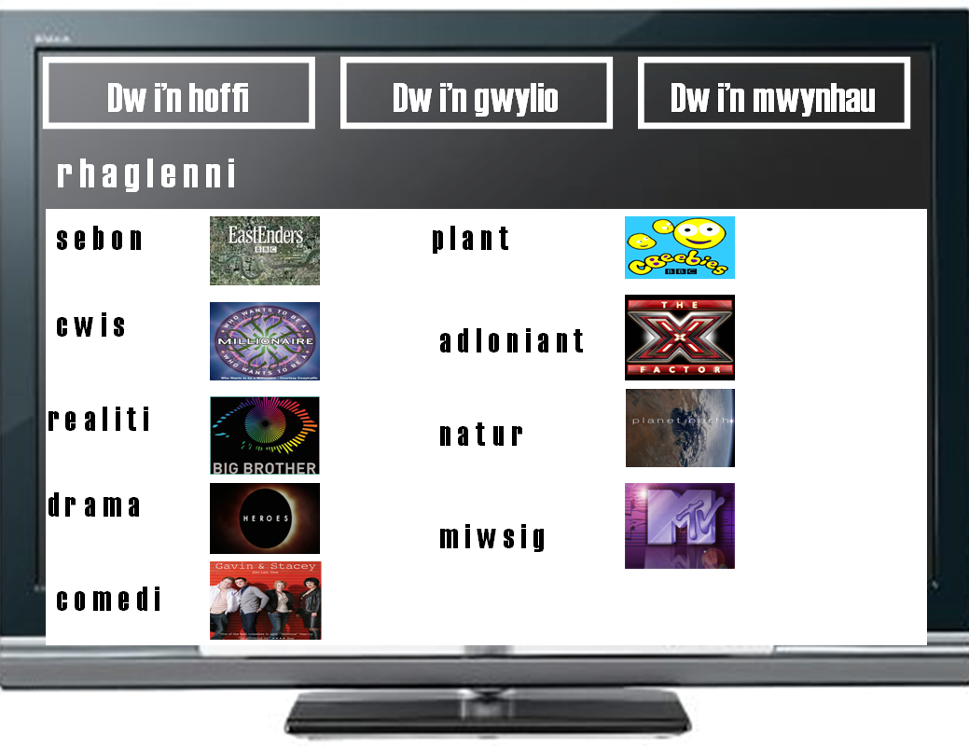 | - Click to reveal the question “Beth wyt ti’n gwylio?” and ask pupils to work in pairs to give an answer before any support is given.  - Click to reveal possible beginnings to the answer, in the correct order.  - Click to reveal “beth wyt ti’n wybod yn barod?” in order to prompt pupils to think of different types of television programmes. This is a timed, two minute exercise.  - Subsequent clicks will reveal anagrams of the adjectives. Discuss with pupils.  - Slide 2 reveals the correct answers. | Urge pupils to use more than one verb.  Good opportunity to revise noun + adjective.
Slides 3-6  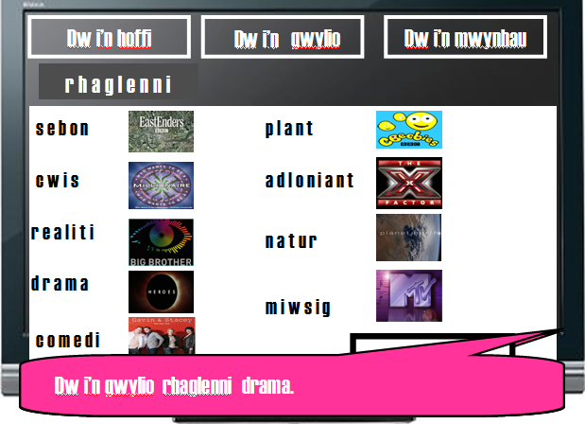 | - Encourage pupils to make sentences using what they see on the whiteboard.  - Click to demonstrate a simple sentence.  - Further clicks in the other slides support pupils in creating extended sentences and show how to include more linking words.  - Encourage pupils to make sentences once more, explaining that their answers should now have improved. | Opportunity for peer assessment; how to improve answers.
Slides 7-10  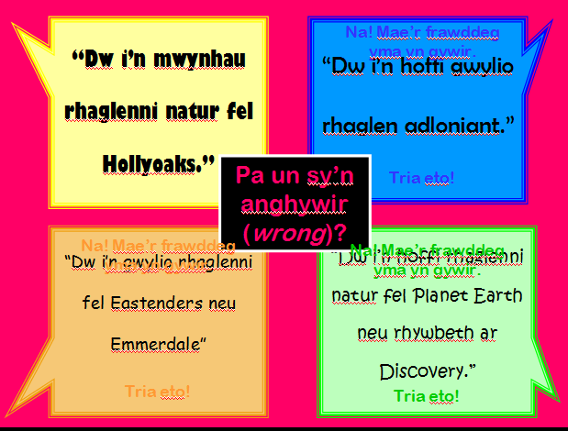  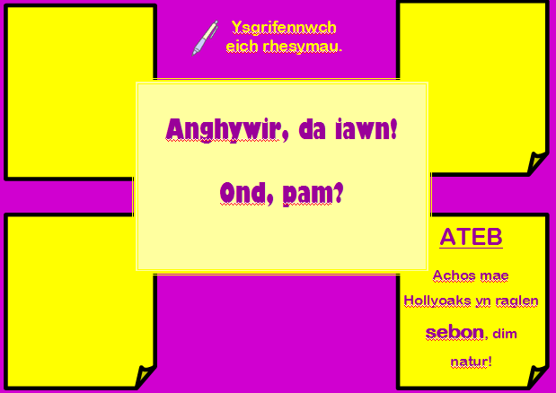 | - Assess pupils’ understanding by asking them to work in groups or pairs to decide which is the odd one out, and to give a reason why.  - Clicking on the wrong answer will reveal that it is incorrect.  - Clicking on the correct answer will take you to another screen that asks for as reason.  - Pupils may use the IWB pen to write their answers in the boxes provided.  - The correct reason will be revealed in the bottom right hand box.  - Pupils to assess their own answers. | Ensure that pupils are giving reasons why in order to demonstrate true understanding.  Allow other pupils to assess whether the reason is sensible.  This slide may be used as a template to make other ‘Odd Ones Out’ in order to tailor for common mistakes different classes may make.
Slides 11-21  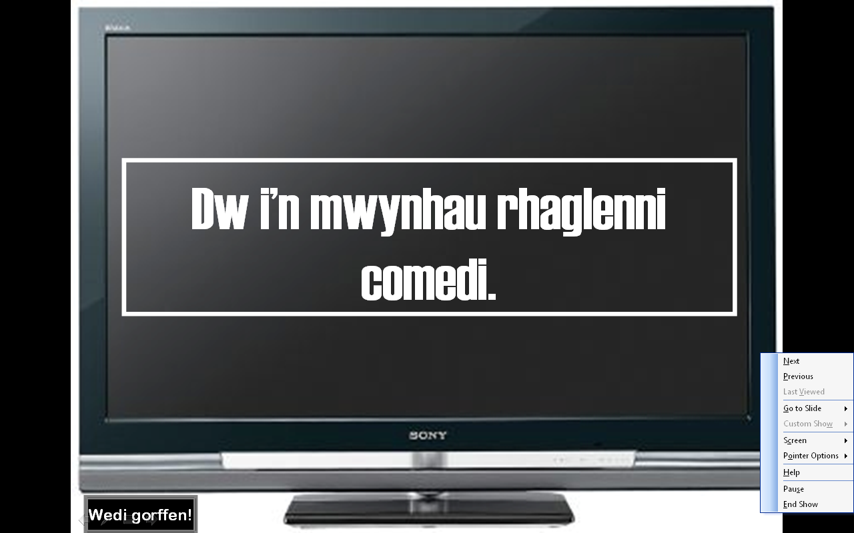 | - Choose a pupil; A.  - Begin the slide show.  - When A yells “stopiwch”, click the right mouse button in the bottom right hand corner of the screen.  - Pupils A chooses another pupil, pupil B.  - Pupil B must translate the sentence displayed.  - The activity continues with pupil B becoming pupil A and so on. | Should the same sentence appear twice, you may choose to continue to another or good practice is to ask for the translation once again in order to assess understanding of different pupils, make it easier for lower ability, and to ensure that all pupils are listening!
Word Document  - Pa Raglenni  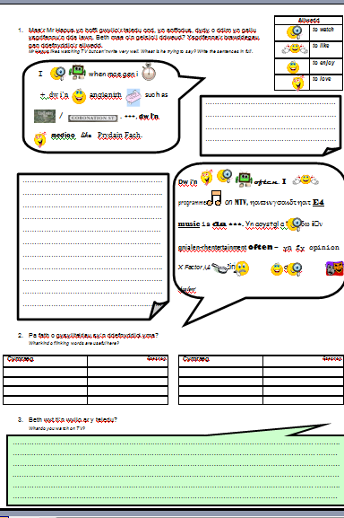 | - Pupils to follow instructions to complete tasks in order to consolidate the learning from above. | Pupils could work in pairs for the thinking skills tasks (1).  Tasks 2 and 3 could be set as a homework.  Task 3 could be used in the following lesson in peer assessment by asking pupils to swap work and assess the good points and what could be improved, giving clear examples. This could also be done as a class by choosing a top, middle and lower ability pupils’ work.

